OutRun Enhanced v1.0.3
This is an updated version of OutRun, Sega's seminal arcade racer. It is intended to be programmed to EPROMs and used with the original arcade hardware.

Enhancements:
- High score saving using existing capacitor-powered RAM (no hardware modification or NVRAM required)
Originally, the game only stored a small amount of bookkeeping data in the "backup RAM". This enhanced version uses some of the significant amount of unused capacitor-powered low-power RAM present to store the high-score table.
A factory original OutRun board uses a 0.1F capacitor to provide power to the RAM. Under normal conditions, it can only be expected to provide power for about one week between power cycles, depending on the power consumption of your RAM ICs, the condition of your capacitor, ambient temperature, etc.
This kit contains a 1.0F supercapacitor, which greatly improves this back-up time, and longevity of data storage.
If the high-score table becomes corrupted, or the user wishes to erase or reset them, enter diagnostic mode and perform a BACK UP RAM CLEAR. This will reset the high score table to the factory defaults.
- Improved freeplay mode with attract; press start to begin
Originally, with freeplay mode selected by the dipswitches, the game would never enter attract mode. It immediately went to the music selection screen when a game was over. If unattended, it would time out and start a game; the game (and music) would play, after which then the cycle would start again at the music selection screen.
Improved freeplay mode DOES allow attract mode (no automatic credit is given). To begin a game in freeplay mode, press the START button. This "coins up" the game, and proceeds to the music selection screen.
Note: Freeplay attract mode will only occur when there are NO CREDITS; if multiple credits are inserted, the game will still automatically start until no credits remain.
- Music is played during the music selection (radio dial) screen
This version allows you to preview the music selected before starting the race. The original only played the "waves" sound on this screen.
- Dipswitch-selectable "MPH" / "km/h" speed display
An optional enhancement to display your speed in MPH rather than km/h. This feature can be enabled by setting dipswitch B, position 4.

Bug fixes:
- Spurious sound in attract mode
A bug occurred with the dipswitches set to have attract mode audio ("advertise sound") OFF.
During attract mode, occasionally the Ferrari would be mid-crash when the demo paused to display the title screen. This would sometimes cause emission of a brief tire-screeching sound. This bug has been fixed in the enhanced edition.
- Misplaced tile on music select screen (above steering wheel)
This tile appeared in the far left hand column. It may have been visible depending on your monitor configuration.
- Mixed up ROM ID numbers on Memory Test diagnostic screen
When running the memory test, the program ROMs were misreported. Each pair of interleaved ROMs was reversed. This version will report the correct ICs as either good or bad.
- Incorrect sprite zoom lookup table
OutRun uses a lookup table to set the horizontal and vertical zoom values of sprites based on their z co-ordinate.
Unfortunately, one of the vertical zoom entries in this table is incorrect. If you drive as slowly as possibly by gently tapping the accelerator, there is a single position where sprites snap to an incorrect vertical zoom value.
This causes sprites to clip incorrectly and jolt to a different offset. This version fixes the erroneous value in the table.

Installation Instructions
Disclaimer: Installation of this kit involves removing and installing socketed ICs, desoldering, and soldering. If you are uncomfortable with any of these tasks, please ask for assistance! I cannot be held responsible for any damage to the kit, your board, or yourself!

Install the programmed EPROMs at their respective locations on the main CPU PCB:
IC117, IC118, IC132 & IC133
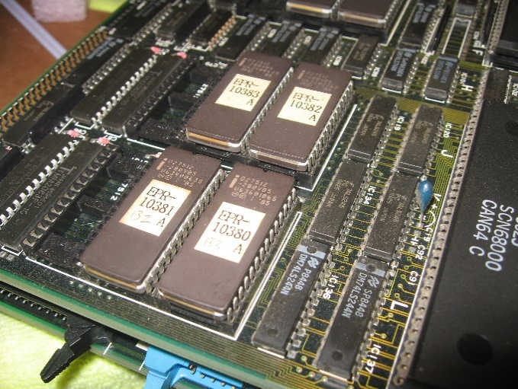 | 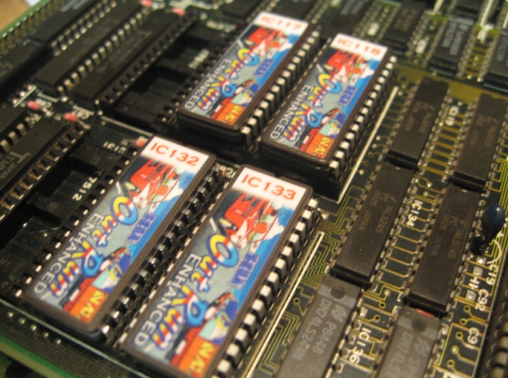
Remove the existing ICs by inserting a small flathead screwdriver (micro type works well) beneath the chip and slowly prying up against the socket, repeat on the other side. Continue this method, rocking back and forth, until the entire chip is completely worked out of the socket.
Insert the new chips into their respective locations on the board, minding their orientation. The notch on the chip will be silkscreened on to the board, which matches the notch on the chip.
The label placement may or may not match this picture. Always use the notch to ensure proper orientation.

Install the supercapacitor:
Desolder the old .1F capacitor located at C109, and install the new provided 1.0F supercapacitor.
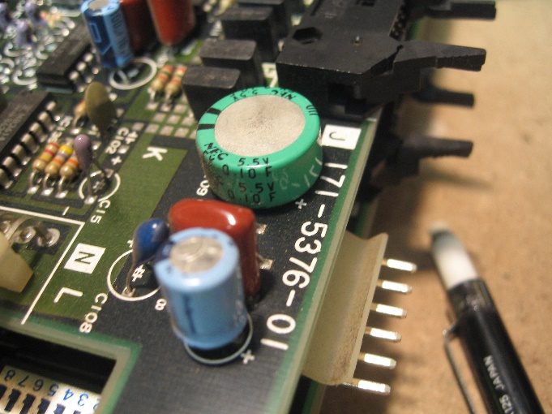 | 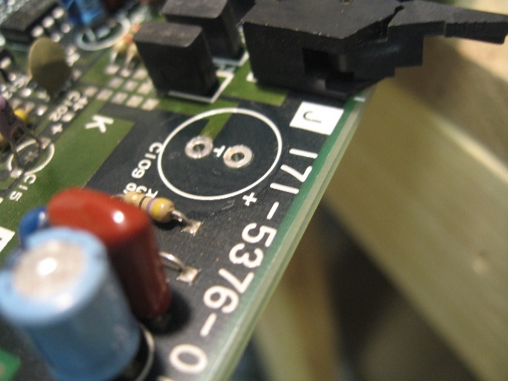

Using your preferred method of desoldering (solder sucker/puller, solder wick, or desoldering iron), remove the solder from the two points on C109, and remove the old cap.
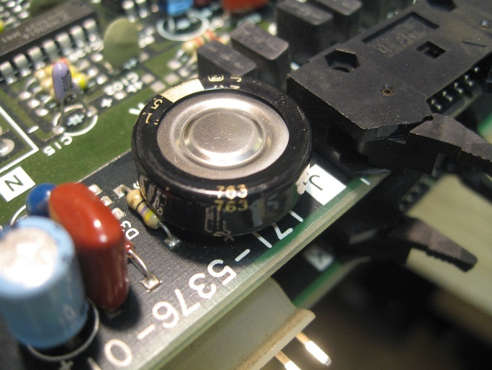
Solder the new capacitor into place, minding the polarity. The positive terminal is always silkscreened with a (+) symbol on the board. In this case, the negative terminal faces the inside of the board, and is marked by the large stripe on the cap.
This new capacitor will provide years of high-score table storage, and can withstand several months between game power cycles.

That’s it, you’re done! Game on…

